**Objectives:**



Microsoft Office Clip Art

Presentational Writing - Students can provide physical descriptions and personality traits in a persuasive format, posted on a school blog (Blackboard, Canvas, etc.).

Interpersonal Speaking and Listening - Students can solicit and provide specific information to conduct an interview. Students can analyze the gathered information and select the best choice to meet specific criteria.

**Person A (promoting male TA):** You are an exchange student in China.  You are helping your TA find a date, in hope that they will fall in love.  Your TA is a male Chinese doctoral candidate. You are eager to end his singlehood. After reading the many examples from this unit, you are aware of the dating scene and criteria for friend-seeking in China.  You will create an advertisement providing your TA’s basic information, physical and personality descriptions. You will also solicit candidates on a public dating blog. You will conduct a mock phone interview for their physical and personality descriptions. At the end, you will choose the best candidate and provide the reasons for your selection.

**Person B (promoting female TA):** You are an exchange student in China.  You are helping your TA find a date, in hope that they will fall in love.  Your TA is a female Chinese doctoral candidate. You are eager to end her singlehood. After reading the many examples from this unit, you are aware of the dating scene and criteria for friend-seeking in China.  You will create an advertisement providing your TA’s basic information, physical and personality descriptions. You will also solicit candidates on a public dating blog. You will conduct a mock phone interview for their physical and personality descriptions. At the end, you will choose the best candidate and provide the reasons for your selection.

**Implementation:**

Day 9. Each student will select to be Person A or B. It would be ideal to have an even split of Persons A and B. Students will work on writing the advertisement and post it on the blog.

Day 10. of project. Each student will bring a print copy of their advertisement. The class should form in an inner/outer circle or format conducive to conduct “Speed Dating”. Each student will also receive an interview check list. Person As and Bs will rotate to conduct interview no more than 5 minutes. At the end of all rotations, class will determine how many “matches” have be made. A “match” is made when both parties have selected each other as interested parties. For example, if Person A1 interviews five Person Bs. Person A1 will only have a match if one of the Person B1, B2, B3, B4, B5, also selected Person A1 as a “like”.

Explanatory Image for Teacher’s Reference: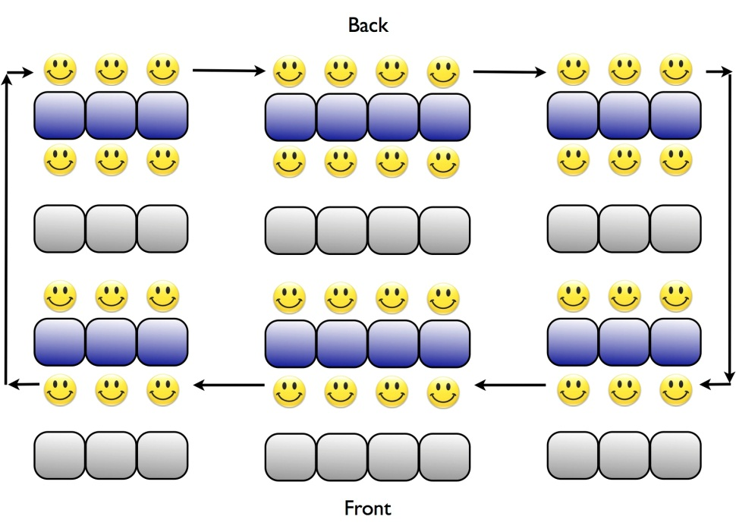

Source: http://amandabickell.files.wordpress.com/2012/05/speed-dating-class-copy.jpg

Writing Rubric for Blog

|  |  |  |  |  |
| --- | --- | --- | --- | --- |
| **Category** | **4** | **3** | **2** | **1** |
| **Task 1:**  Describe your TA | Can write an elaborate series of physical descriptions and personality traits. | Can write an adequate series of physical descriptions and personality traits. | Can write minimal series of physical descriptions and personality traits. | Writing consists of segmented or incomplete sentences on physical descriptions and personality traits. |
| **Task2 :**  Describe your TA’s desired boy/girl friend | Can write an elaborate series of physical descriptions and personality traits. | Can write an adequate series of physical descriptions and personality traits. | Can write minimal series of physical descriptions and personality traits. | Writing consists of segmented or incomplete sentences on physical descriptions and personality traits. |
| **Language:**  (Vocabulary) | Can use an abundance of new vocabulary words in appropriate context, containing less than 2 typographical errors. | Can use adequate amount of new vocabulary words in appropriate context, containing more than 3 typographical errors. | Can minimal amount of new vocabulary words in appropriate context, containing more than 3 typographical errors. | Can minimal amount of new vocabulary words, yet in wrong context, containing more than 3 typographical errors. |
| **Language:**  (Grammar structure) | Can use a variety of grammatical structures, including the two targeted structures in appropriate context. | Can adequate amount of grammatical structures, including one of the targeted structures in appropriate context. | Can minimal amount of grammatical structures, but use the one of the targeted structures incorrectly. | Can minimal amount of grammatical structures, but use none of the targeted structures incorrectly. |
| **Presentational details**  (task completion, presentation-ready) | Final product completes the required tasks, and is presentable for formal setting. | Final product completes the required tasks, and is near presentable for formal setting. | Final product completes one of the required tasks, and does not meet the standards to present at formal setting. | Final product completes the tasks required minimally, and does not meet the standards to present at formal setting. |